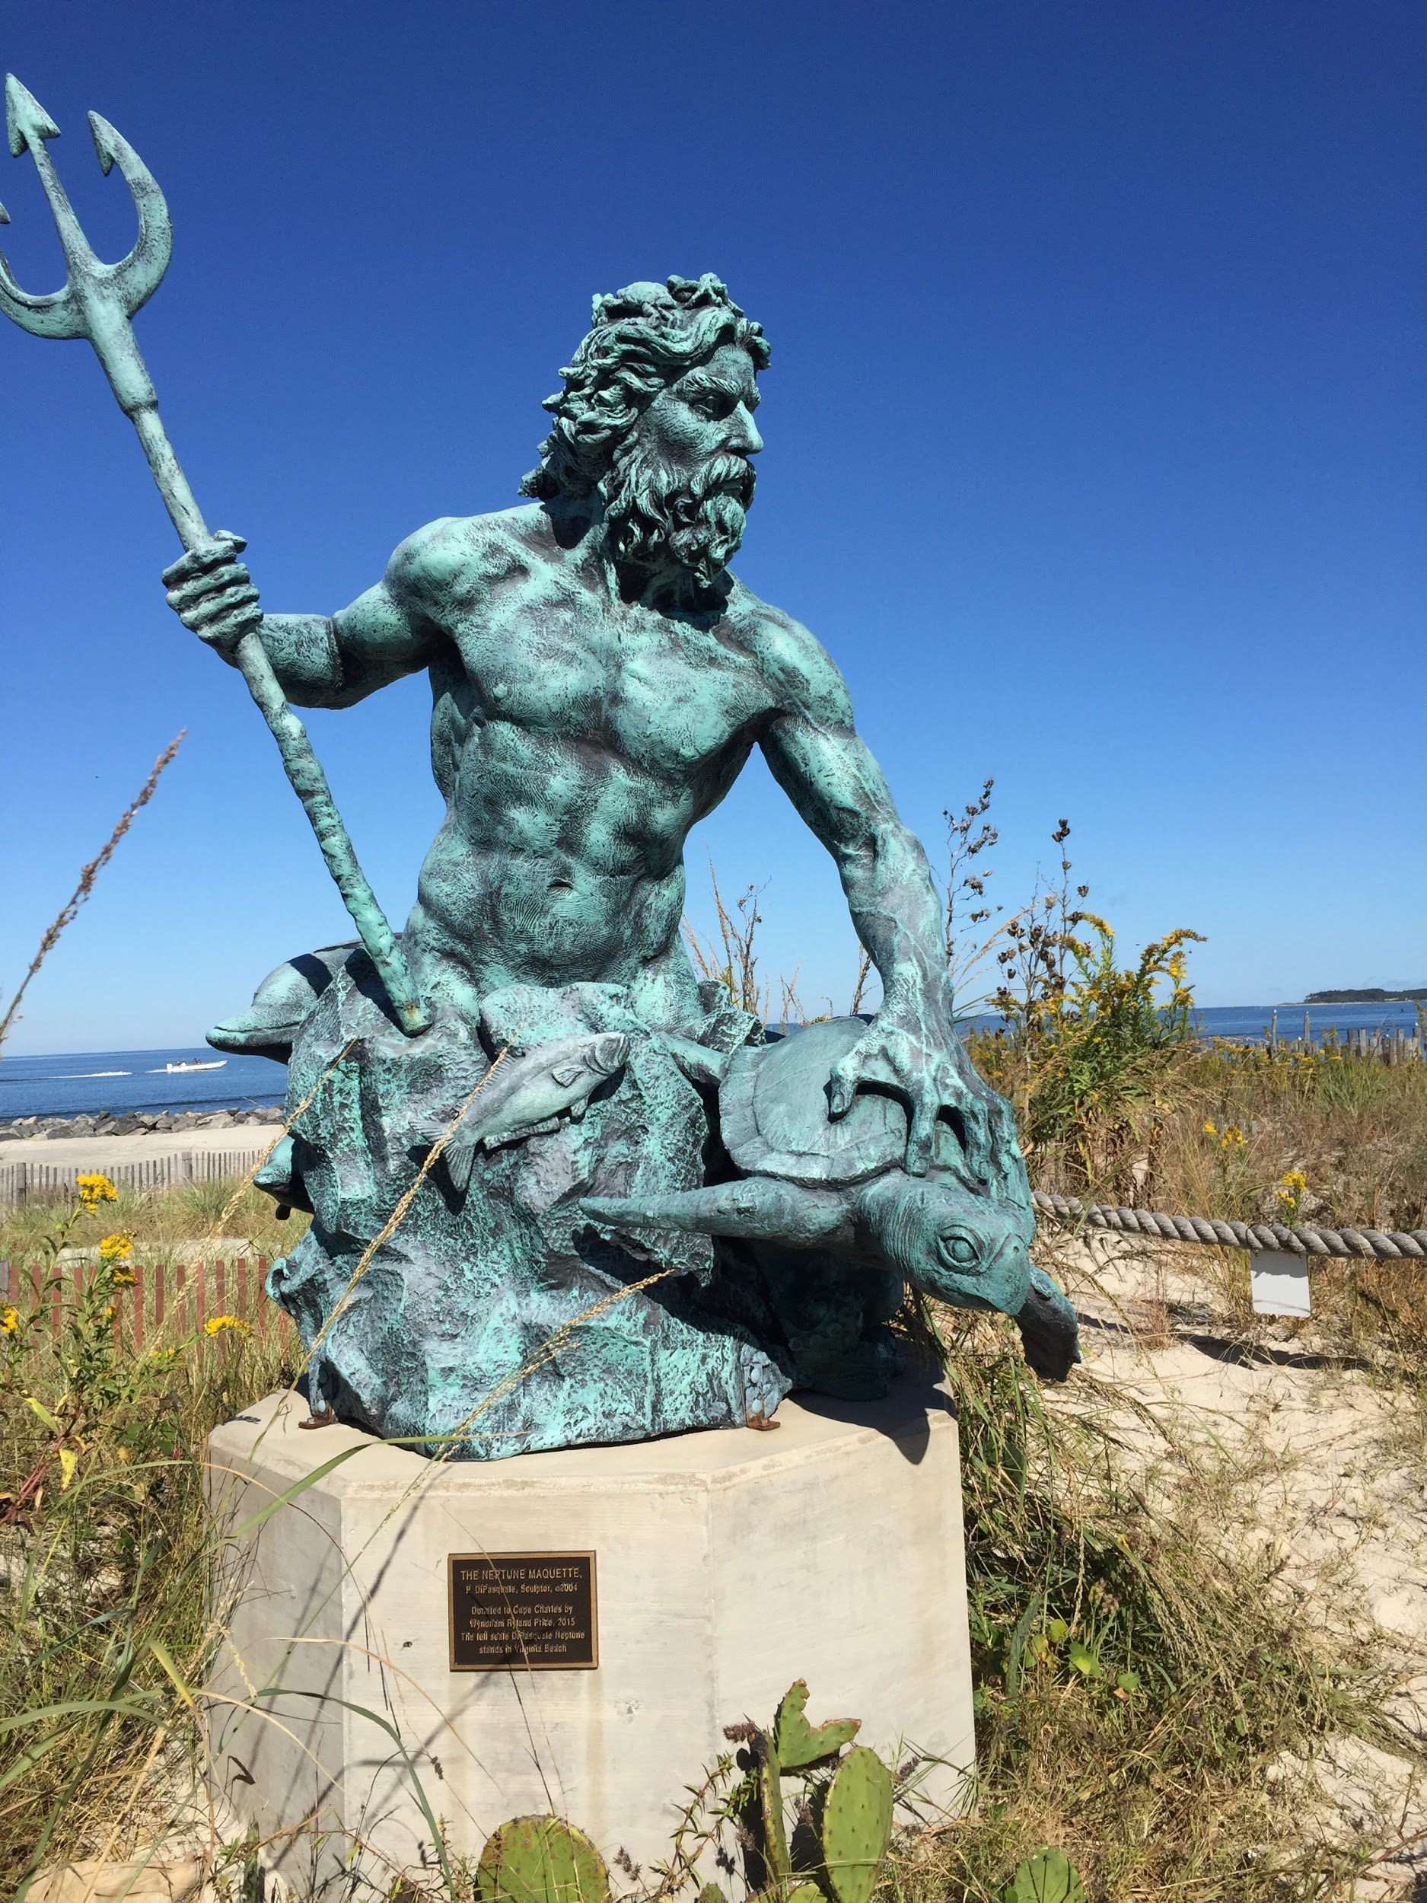

ACS GREAT ROUNDUP 2018: CAPE CHARLES GOES GREEK!
CAPE CHARLES, VIRGINIA
FRIDAY, SATURDAY, AND SUNDAY,
OCTOBER 12, 13, 14, 2018
REGISTRATION FORM

SCHEDULE (the basics)
Friday, October 12, 2018
- Arrive at hotel of choice
- Registration and Gathering—Cape Charles Coffee House, 8am-5pm (http://thecapecharlescoffeehouse.com/)
- Oyster Roast on the Beach! (Venue and Time TBD)
Saturday, October 13, 2018
- Morning and afternoon--activities TBD; check website for updates: www.acsgreatroundup.com
- Great time to get together with smaller groups of friends!
- Gathering Room open: Cape Charles Coffee House, 8a-1pm
- Evening Event—TBD
- Announce next Great Roundup
Sunday, October 14, 2018
- Get together with friends …until we meet again…

REG DEETS:
How many in your party?
ALUMNI NAME (LAST, FIRST, MIDDLE, MAIDEN)
CLASS OF:
ADDRESS - street
ADDRESS - city
ADDRESS - state, zip, country
PHONE:
EMAIL:
BEST WAY TO CONTACT YOU: TEXT PHONE EMAIL USPO
NAME TAG INFORMATION
Your Name - for your name tag:
Guest Name:

EXPENSES TOTAL
Full Registration - PER ADULT # Adults attending: $125.00

Children (6-18) # Children attending: $75.00
Children 0-4 INCLUDED $0.00

Registration / Welcome Packet INCLUDED
Gathering Room INCLUDED
Friday Night Event INCLUDED
Saturday Night Dinner INCLUDED

Hotel ON OWN
Additional monetary support ON OWN
Incidentals / Miscellaneous ON OWN
Air/Ground Transportation ON OWN
TOTAL DUE/CHECK INCLUDED: __________________________________________________

YOUR INFORMATION WILL REMAIN CONFIDENTIAL.

Please make check(s) (installments) payable to:
ACS Great Roundup 2018
c/o Katerina Clifton
6511 Lily Dhu Lane
Falls Church, VA 22044
615-305-3484
PLEASE SEND PAYMENT IN FULL BY JUNE 1, 2018

Your Planning/Plotting Committee: Give one or more of us a shout, if you have any questions.

Dora--CoChair Dora Kitzman Sullivan--'70 dorasullivan8@gmail.com
Katerina--CoChair Katerina Kitzman Clifton--'71 kmc2701@gmail.com
Denah--Past CoChair Denah Lord Shabal - '71 dls0323@att.net
Becky--Silent Auction Rebecca Ann Gleisberg--'70 gleisbergcms@cox.net
Stephanie--Ground Crew Stephanie J Find her on Facebook :-)
Dianne--Greeting Dianne Kambos Hamilton--'70 yassou3@comcast.net
Denny—Music Dennis Lord—’70 Find him on Facebook

SPECIAL STUFF
- IF YOU ARE DRIVING, WOULD YOU BE INTERESTED IN CAR-POOLING WITH SOMEONE TRAVELING FROM YOUR AREA? Let us know, and we’ll connect you with others.

- IF YOU ARE FLYING INTO NORFOLK OR BALTIMORE, LET US KNOW. We'll connect you with others.

- WOULD YOU BE INTERESTED IN SHARING A HOTEL ROOM/RENTAL HOME? Let us know, and we’ll connect you with others.

- DO YOU HAVE ANY DIETARY RESTRICTIONS/REQUESTS?
- DO YOU HAVE ANY SPECIAL NEEDS OR NEED SPECIFIC ACCOMMODATIONS?
- IF YOU HAVE A BUSINESS WITH INFO ON THE INTERNET / FACEBOOK, PLEASE SHARE! WE’LL PUT UP A LINK FOR YOU.

FUN STUFF

Where Am I? Who's Missing?
Know where to find missing friends? Be sure to get in touch with them and invite them to the party.

Our Theme Song!
"All My Friends from Greece"
(Thanks, Matt Barrett)
https://www.youtube.com/watch?v=Tp5mfWlW5Cs

DRESS for the weekend: Comfort/Casual is Key.
Bring a jacket.
If you’re driving, you might want to bring a beach chair.

Watch for event updates on The Evzone and website (www.acsgreatroundup.com.)

Looking forward to seeing you in Cape Charles!

